WOODLANDS CHURCH – WOODLANDS CAMPUS

WEDDING POLICIES & PROCEDURES

C:\Users\vdimmitt\AppData\Local\Microsoft\Windows\Temporary Internet Files\Content.IE5\J42YSR8T\MC900438273[1].wmf

*“For this reason, a man will leave his father and mother and be united to his wife,*

*and the two will become one flesh. So, they are no longer two but one.*

*Therefore, what God has joined together, let man not separate.”*

Mark 10:7-9 (NIV)

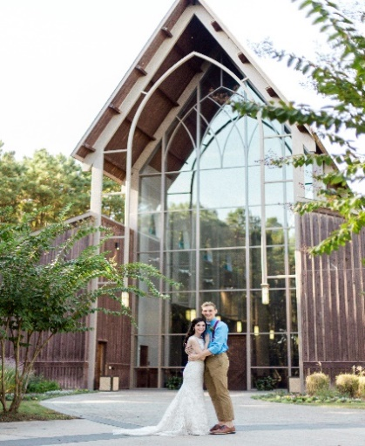

CONGRATULATIONS ON YOUR ENGAGEMENT

Thank you for expressing interest in having your wedding at Woodlands Church, Woodlands Campus. We greatly value the marriage relationship and will do our best to make your wedding day one that glorifies God and is the joyous occasion you anticipate. This document provides information about having your wedding at the Chapel in The Woods at Woodlands Church. Please contact our Wedding Services Department at 281.367.1900 for answers to questions and additional information.

ENGAGEMENT COMMITMENTS

We believe that marriage is a holy and sacred gift from God, so it is our intent that couples approach marriage according to biblical standards and in a way that is pleasing to God. Therefore, we require that you make the following engagement commitments, in order to be married at Woodlands Church by a Woodlands Church pastor.

BELIEFS

We believe God intends a marriage relationship to be equally yoked and that Christians should only marry Christians, so we encourage that both the bride and groom confirm their commitment to Jesus Christ as Lord and Savior.

PURITY

The sexual relationship has been designed by God and intended for marriage. We ask that you agree to abstain from any sexual relationship until after the ceremony. Furthermore, *a living arrangement that includes cohabitation prior to the wedding is a compromise of Christian values, so we require that you agree to separate living arrangements until after the ceremony. Please contact us, if you have any questions. We desire to encourage and promote a healthy biblical start to every marriage.*

FAITHFULNESS

The church is God’s primary tool for building strong marriages, so we encourage you to find a place to serve and pursue a lifestyle of faithfulness to your church family.

WEDDING POLICIES & PROCEDURES – PAGE 1

MARRIAGE PREPARATIONS

ELIGIBILITY

Membership is not required to have a wedding at Woodlands Church. However, because of the investment our members have made to enable our growth, we offer them preferred scheduling and rates.

MEMBERS

Those who have attended the Membership Class are considered members and will receive a discount. *The step to become a member of Woodlands Church must be completed at least three (3) months prior to submitting a Wedding Application*. Members may make wedding reservations up to fifteen (15) months in advance, subject to availability. **Membership rate applies only when using a Woodlands Church pastor to officiate the wedding.**

NON-MEMBERS

Non-members are those who have not attended Membership Class. This includes regular attenders and visitors. Members who have completed the membership class *less* than three (3) months of submitting a Wedding Application will be given the non-member rate. Those in this category may make wedding reservations up to twelve (12) months in advance, subject to availability.

PRE-MARRIAGE PREPARATION

All couples getting married at Woodlands Church, by a Woodlands Church pastor, are required to fulfill the following preparation steps: *Due to time constraints, our Senior Pastor and Executive Pastor are not available to officiate.* *(Note: Out of state brides will need to plan ahead to meet these requirements. We do not offer online courses.)*

1. Complete an online marriage survey. After both of you complete the survey, you will meet with the presiding pastor for a one-hour “get acquainted” session. He will also review the results of your survey and discuss your wedding vows, at this meeting. Sometimes, the pastors will require more than one meeting. The survey will be sent out about ninety (90) days prior to the wedding date.
2. Register and complete a pre-marital workshop prior to your wedding. This workshop is offered once each calendar quarter, so it is important that you schedule this early in the process. Please contact the Wedding Services Department 281.367.1900 for available dates. The workshop is accredited through *Twogether In Texas.*

GUEST PASTORS

Woodlands Church welcomes guest pastors to officiate weddings. All guest pastors must be approved by Woodlands Church. Guest pastors must limit the ceremony to thirty (30) minutes. If you choose to secure your own pastor, you are exempt from the above Marriage Preparation requirements which are included in the wedding fees. *If for any reason the officiating guest pastor cannot perform his contracted duties, a Woodlands Church pastor* ***CANNOT*** *step in to officiate. We reserve the right to deny officiants that do not meet our requirements. A guest pastor MUST be established at the time the application is submitted. Any changes made to the application regarding a guest pastor must be made in writing a minimum of three (3) months prior to the wedding date.* Members using a guest pastor will not receive membership rate.

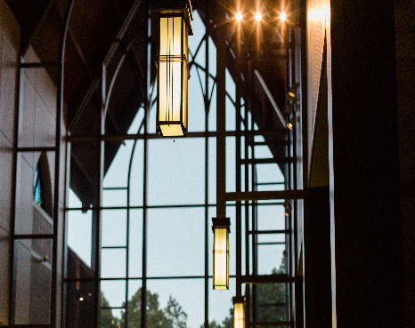 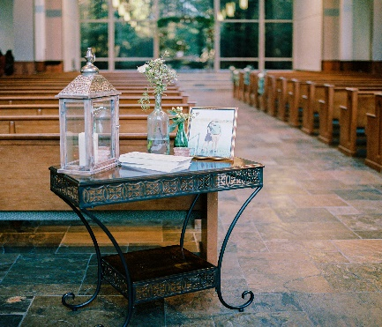

WEDDING POLICIES & PROCEDURES – PAGE 2

WEDDING RESERVATIONS

Please read our Policies/Guidelines prior to securing your date. Contact the Wedding department to make sure your preferred date is available at 281.367.1900.

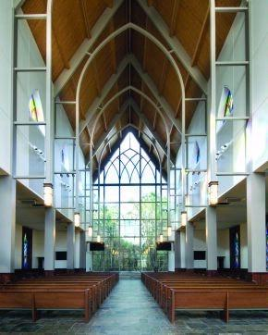

WEDDING DAYS AND TIMES

Chapel in the Woods/Off-Campus Baptismal Pool (located behind sanctuary)

Friday at 7:00pm Friday at 6:00pm (Day Light Savings time)

Saturday at 11:00am or 4:00pm Saturday at 10:00am

***(These times are not flexible)***

Rehearsal for chapel ceremony will be held the day before the wedding at 3:00pm or 4:00pm.

Our Worship Center, Atrium and Prayer Fountain (cross) are not available for wedding ceremonies. Weddings cannot be scheduled during the following holiday weekends: New Year’s, Easter, Memorial Day, Independence Day, Labor Day, Thanksgiving and Christmas.

**Note: We do not offer a reception venue.**

FEES/CANCELLATIONS

Wedding Fees

The wedding fee for the chapel includes pastor services, wedding coordinator, pre-marriage counseling, administrative fees, chapel coordinators, sound and lighting engineer, maintenance personnel, utilities, pre-marital workshop, and online marriage survey. The pre-marital workshop and online marriage survey are a part of your wedding fees, regardless of using a Woodlands Church Pastor or a guest Pastor.

* **Chapel in The Woods** *(seats 400)*

Member Rate: $1,250; Non-Member Rate: $2,250

* **Baptismal Pool** *(seats 40)* **or Off-Campus Location**

Member Rate: $550; Non-Member Rate: $1,000

Your date for the chapel will be secured once you have submitted an application and a $500 non-refundable retainer. The remainder of your wedding fees must be paid-in-full ninety (90) days prior to your wedding date. Late fees will apply.

For baptismal pool or off-campus weddings, the full wedding fee must be paid at the time of securing a date.

Cancellations/Reschedules

If you cancel your secured date for any reason, you will NOT be refunded. You may reschedule your date one time without penalty. After a second rescheduling of your wedding date, a $500.00 fee will be required prior to rescheduling.

WEDDING POLICIES & PROCEDURES – PAGE 3

WEDDING GUIDELINES

CHAPEL COORDINATORS

Woodlands Church will assign two chapel coordinators about three (3) months prior to your wedding date. They will work with you during your wedding in the chapel. They do not offer services outside of the chapel. The coordinators will contact you about one (1) week prior to your wedding, to schedule a meeting to review the details of your ceremony, including the order of service. They will ensure that the rehearsal and ceremony preparations are in place and they will be present during all activities in the chapel. Outside event planners are welcome and will agree to work under the direction of the coordinators provided by Woodlands Church. Out of state brides will need to plan in advance to meet this requirement.

WEDDING MUSIC

As you consider music for your wedding, please make selections that are suitable for a worship service. All instrumental music, as well as, songs with lyrics, must be appropriate for the chapel. Please download ceremony song choices onto a flash drive and bring it to the coordinator meeting. You are responsible for contacting and contracting any vocalists and/or instrumentalists you choose to perform at your ceremony. *Due to rehearsals for weekend services, Woodlands Church musicians are not available for hire*. A sound and lighting engineer will be available to set-up any hired musicians, ninety (90) minutes prior to the wedding.

FLOWERS AND DECORATIONS

Your florist will have access to the chapel two hours prior to the scheduled time of your wedding. *All flowers and decorations must be removed immediately following the wedding ceremony and pictures within the allotted time.* The church does not store any wedding decorations the day before or after the ceremony. Taper candles must be dripless. Votive or pillar candles must be used in hurricane lamps or lanterns. In order to protect chapel finishing’s, plastic materials must be placed under all floral arrangements. Please be careful not to mar woodwork or flooring. Nails, staples, adhesives, etc., are not permitted. Pew markers must be secured with padded or plastic hooks. Real rose petals may not be dropped on the slate floor (silk only). Confetti (including biodegradable confetti), birdseed, rice, glitter, sparklers or sky lanterns are not to be used in church buildings or on church grounds. Please do not leave or store empty boquet vases in the bride’s room or under the counter. You are responsible for disposing anything that is brough into the chapel. Chapel facilities and furniture may not be altered or moved. During the month of December, the chapel will be decorated for Christmas. These decorations may not be altered or moved.

PHOTOGRAPHY AND VIDEOTAPING

Photographs and videotape should be taken in a way that does not disrupt the wedding ceremony. No flash photography should be used during the ceremony. We ask that photographers refrain from being on the altar to take photos during the ceremony. We allow thirty (30) minutes for photographers to take pictures immediately following the ceremony. Ceremonies that begin late will take away from allotted photography time. The chapel is available (to contracted brides) for bridal portraits by appointment only. Please contact our Wedding Services Department at 281.367.1900 to schedule an appointment. The people involved in videotaping and photographing your wedding should be dressed appropriately for the wedding. Our sound and light engineer is not responsible for audio recordings of the ceremony. The bride and groom are responsible for informing the photographer/videographer of these guidelines.

REHEARSAL

If applicable, your wedding rehearsal will be scheduled for one hour the day before your wedding date. Rehearsal times are: 3:00pm-4:00pm or 4:00pm-5:00pm. Once your date is secured through our wedding website, you will be notified of your rehearsal date/time. Since rehearsals are sometimes scheduled back-to-back, you must adhere to the scheduled start and end times for your rehearsal. Your chapel coordinators will conduct your rehearsal and act on behalf of the pastor who is marrying you, if he is unable to attend. It is important that all members of your wedding party attend the rehearsal and arrive on time. Parents of the bride and groom are encouraged to attend as well. Because time for the rehearsal is limited, vocalists and instrumentalists will not rehearse until the day of the ceremony. A sound and light engineer will be available for a sound check ninety (90) minutes prior to the ceremony start time.

WEDDING POLICIES & PROCEDURE – PAGE 4

WEDDING PARTY

It is expected that members of the wedding party will understand that the church is a house of God and will conduct themselves in a manner befitting a place of worship. Dressing rooms will be provided for the bride and groom in the chapel. These rooms will be available to the wedding party two hours before the ceremony begins. The church will not be responsible or liable for personal items such as clothing, phones, purses, etc., brought to the church if such items are lost, stolen or damaged. Prior to both the rehearsal and wedding, it is expected that members of the wedding party will refrain from using alcoholic beverages or drugs. No alcoholic beverages or drugs may be brought onto or consumed on church premises at any time, including parking lots. In addition, Woodlands Church is a non-smoking campus. The use of any tobacco products, E-cigarettes, vapors, etc. is prohibited. Note: No animals or weapons of any kind are allowed in the chapel.

CONTRACTED CHAPEL TIME

We offer two ceremony start times on Saturdays (11:00am or 4:00pm). For an 11:00am wedding, your contracted time in the chapel is 9:00am – 12:15pm. For a 4:00pm wedding, your contracted time in the chapel is 2:00pm – 5:15pm. On Fridays, we offer a 7:00pm ceremony start time and your contracted time in the chapel is 5:00pm – 8:15pm. Wedding Day timeline is as follows: Arrive at Chapel two (2) hours prior to ceremony start time. Ceremony will begin on time and will last no longer than thirty (30) minutes. We do not allow corporate communion. Only private communion is permitted. Photographers will be given thirty (30) immediately following ceremony. Ceremonies that start late or last longer than 30 minutes will cut into the photography time. Cleanup time is fifteen (15) minutes. It is suggested that there be a House Party (group of people who are not in the wedding or pictures) be assigned to assist with the removal of all items brought into the chapel. *These contracted times are non-negotiable. Any disregard to these agreed times for the chapel will result in a forfeit of your deposit.*

OFF CAMPUS WEDDINGS

A Woodlands Church pastor can sometimes preside over a wedding that is off campus. The venue cannot be more than twenty (20) miles from the church. All requirements for Engagement Commitment and Marriage Preparations will apply. The fee for an off-campus wedding will be the same as the fee for Baptismal Pool wedding. For pricing information, please refer to the *Wedding Fees* section under FEES/DEPOSITS/CANCELLATIONS. The ceremony start time, for an off-campus wedding, must be no later than 4:00pm on a Saturday. Pastors are not available for weddings on Sundays.

BAPTISMAL POOL WEDDINGS

We offer weddings at our small Baptismal Pool at Woodlands Church (Located behind Sanctuary). The Prayer Fountain (cross) is not offered as a wedding site. For available dates/times, please refer to the *Wedding Reservations* section. During the winter months (Standard Time), we do not offer the Friday 6:00pm time slot. We can provide seating for a maximum of 40 guests. We do not offer a rehearsal day for Baptismal Pool weddings. Music can be played by acoustic instruments or through a battery powered device. Our coordinators will meet with the bride/groom about one (1) week prior to the ceremony. The coordinators will do a walk-through of the ceremony after the meeting. In the event of inclement weather, the wedding will be held indoors in the lobby area of WC Kids near the South East entrance of the church. The chapel will not be offered as an option for inclement weather.

CHAPEL TOURS

We offer tours of the chapel on Tuesdays and Thursdays, by appointment only. Please call 281.367.1900 to schedule an appointment.

*Any violation of these rules will result in automatic loss of your deposit and may result in cancellation of the wedding. It is the obligation of the bride and groom to ensure that all members of the wedding party and all outside service providers understand these rules and abide by them.*

C:\Users\vdimmitt\AppData\Local\Microsoft\Windows\Temporary Internet Files\Content.IE5\J42YSR8T\MC900438273[1].wmf

Woodlands Church

Woodlands Campus

Wedding Policies & Procedures

January 2021

WEDDING POLICIES & PROCEDURE – PAGE 5